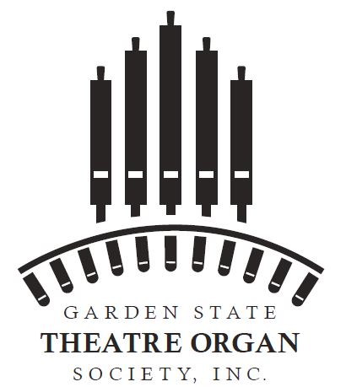
Membership Application
NAME________________________________________
ADDRESS_____________________________________
______________________________________________
CITY _________________________________________
STATE _______ ZIP_____________________________
PHONE: (_______) - ________ ___________________
E-MAIL: (Required)_______________________________________
First Year Dues for BRAND NEW MEMBERS are only
$10 US Currency.(This is a limited time offer and may
be withdrawn at any time. Returning members with
lapsed memberships are not eligible. Dues for
subsequent years will be at the regular rate described
below. This offer provides all the benefits described below, except that the Pedals and Pipes Newsletter, in full color, is only available as a pdf file sent to your e-mail address.)
Regular GSTOS annual dues are only $25 US Currency (either as a single,
or family membership), which entitles you to:
Receive our Pedals & Pipes newsletter
Obtain one free ticket to any one of our public concerts
Attend any of our members only meetings at private homes
If you wish to be a GSTOS voting member, you must also join our parent organization, the American Theatre Organ Society. Added benefits include the bi-monthly Theatre Organ Magazine. To join ATOS visit www.atos.org .
Do you currently play piano? ______
Organ? ______ Other? _______
Would you consider becoming an Organ Crew
Member? Yes____ No____ Not Sure____.
Are you a member in another Organ Group?
Yes___ No___ If yes, please indicate________

Make check or money order payable to GSTOS
and mail to: GSTOS
PO Box 65, Rahway, NJ 07065

